**EXPERIMENT 3**

# Introduction to Microsoft SQL Server DBMS

**Objective**

* Familiarize students with SQL which is a RDMS by Microsoft
* Table creation, definition through script.
* Data import and export from files to DBMS (tables) using SQL import export utility.

## Exercise 1: Creating relational database using SQL server management studio designer

**Step 1: Open SQL server management studio**

Start->Program Files ->Microsoft SQL server 2014 -> SQL server management studio

Enter your server name as “172.16.1.158” username as “sa” password as “12345678” as shown in figure1 below

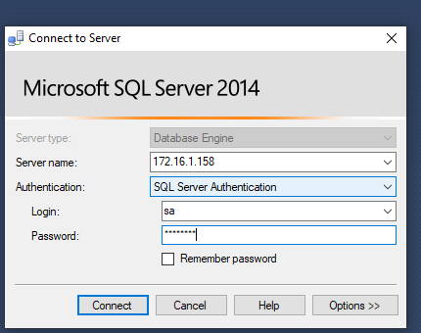

**Figure 1**

To add new Database Right click on Database folder and select New Database. Name this database as your rollnumber (beginning with letter L) as shown in figure2 below.

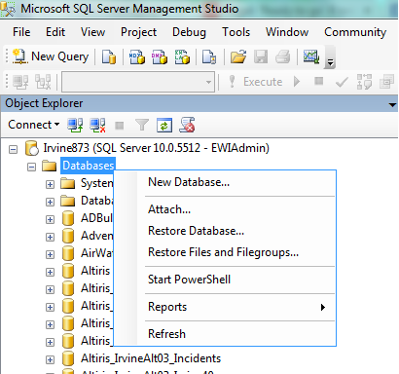

**Figure 2**

**Step 2: Creating Tables through script in your database**

The SQL DDL code given in the company.sql file (present in the lab folder) belongs to the relational model shown in Figure3 below:

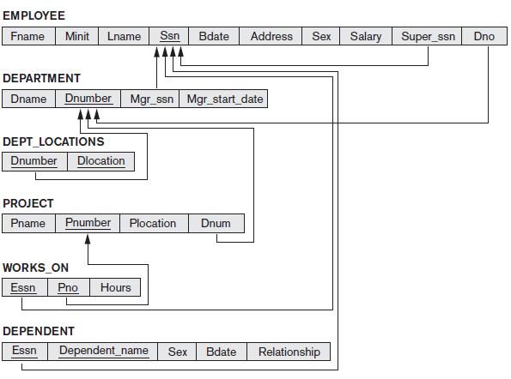

**Figure 3**

Please spend a few minutes going through the code in the company.sql file.

Now click on “New Query” after selecting your own database in the drop down as shown in Figure 4

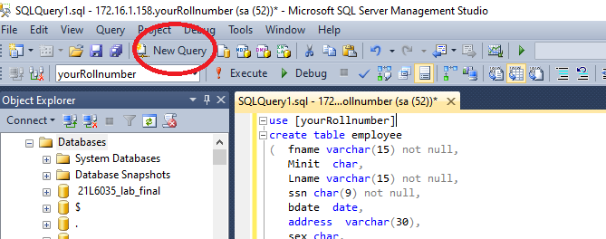

**Figure 4**

* In the SQL window that opens, copy the code from company.sql file and, paste it as shown in Figure 5.
* Change use [your database] to the name of the database you created (your rollnumber).
* Now click on execute.
* If all goes well, you would see “command executed successfully” message and on expanding the tables folder in your database you would see the table that have just been created for you.

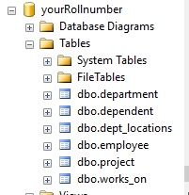

**Figure 5**

## Exercise 2: Import data in to employee table using Import Export utility

Start->Program Files ->Microsoft SQL server 2014 -> SQL server 2014 Import and Export data 32 bits

Select your Data source as Microsoft Excel as shown in Figure 6 (as data that you are going to import is present in the company.xls file. You have to repeat the following steps for all the tables that you created in Exercise1.

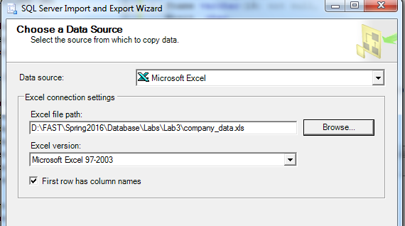

**Figure 6**

Don’t forget to check “First row has column names”. Click on Next.

Select your destination database as shown in Figure 7.

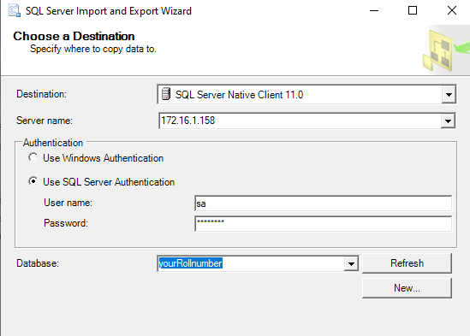

**Figure 7**

Click Next button .

Select the first option on next screen as given below in figure 8

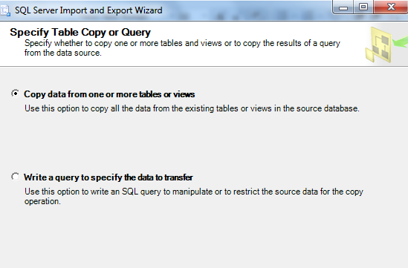

**Figure 8**

In the next screen that comes up, please make sure you have selected everything as given in the screen shot below in figure9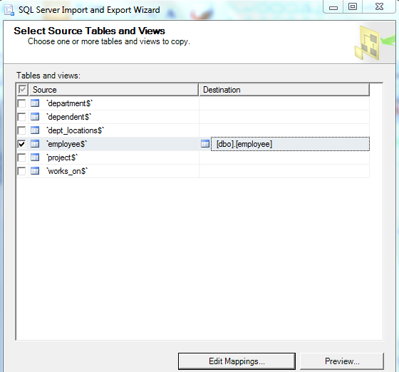

**Figure 9**

Now click on “Edit Mappings” button and on the next screen make sure that the destination columns are correctly selected as shown in figure10 below.

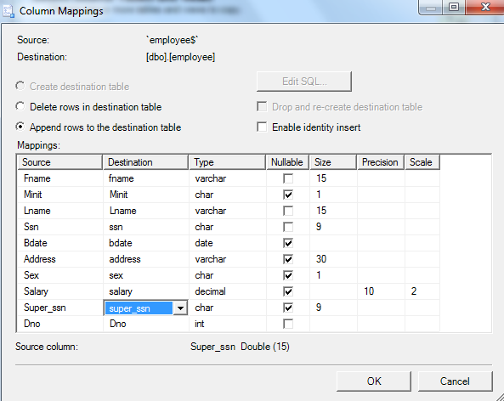

**Figure 10**

Click OK and then click Next to move to next screen till you get to the screen with “Finish” Button. In the screen that comes up (figure11) you would see that 8 rows of data would have been transferred to the employee table, if everything went fine.

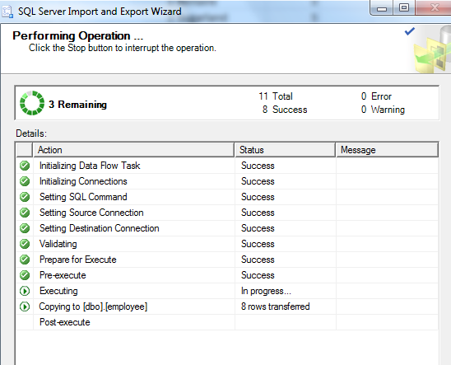

**Figure 11**

**Selecting Data**

**Task 1: Selecting data from the table using selection Query**

Start->Program Files ->SQL server 2014 -> Management studio

Select your database

Open Query window and type

Select * from employee

Execute Query.

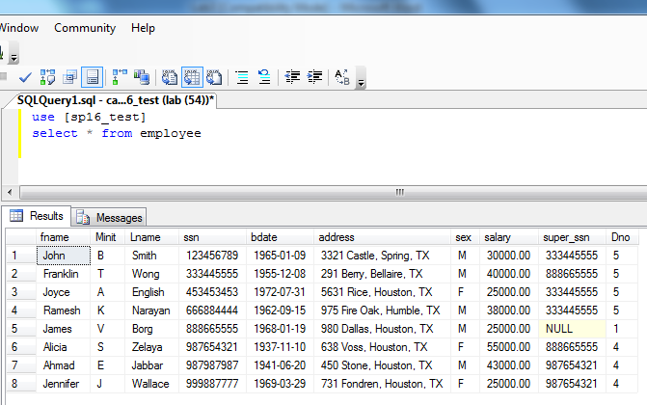

**Figure 12**

## Exercise 3: Import data in to the other tables of company database using Import Export utility

## Please repeat the steps in Exercise2 to import data into the rest of the tables. Please make sure that you follow the following order while importing the data

1. Dependent table
2. Department table
3. Project table
4. Dept_locations table
5. Works_on table

Exercise 4: Login to SQL Server and run the following script in SQL Server after having successfully imported data in all the tables to get your worked checked. Please attach a screenshot of the output in the space below:

use [your database]

select * from employee

select * from department

select * from dependent

select * from dept_locations

select * from project

select * from works_on

